Wire Frames

By: Team BattleYA

Matteo La Barbera

NHL Stenden

# Wireframe & User Interface Explanation

Here the Wireframe of the game will be shown, showing all game states and their proposed sketches in our design. It will be heavily influenced by other strategy games, like Age of Empires. Alongside the wireframe, will be a few UI sketches that our team has designed and might utilize in the project. This is also our user interface design in its whole.

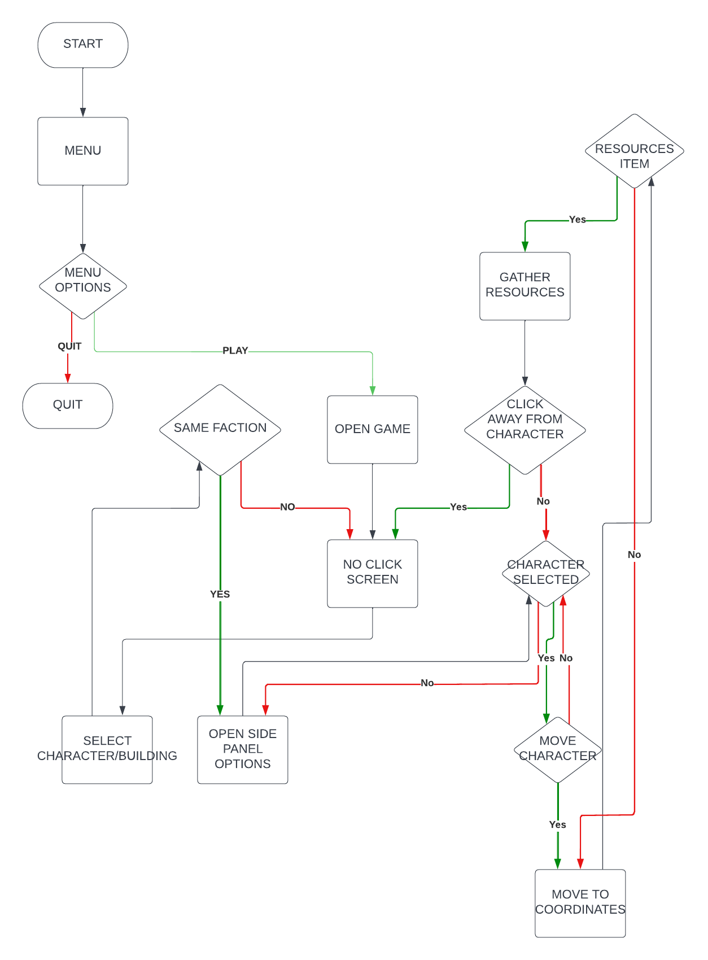

## Menu WireFrame

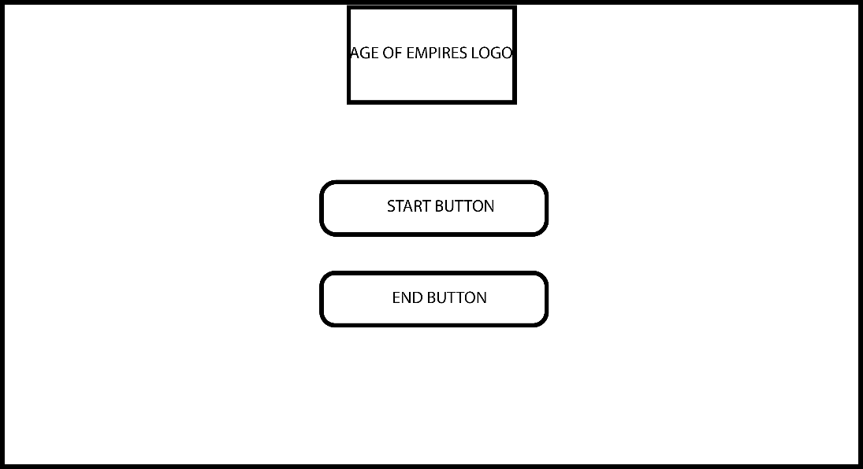

The Menu is the opening game for the page. The menu consists of the logo which is clickable to launch the game as well as a start button to enter the game and an end button to exit the game. They are centered by width.

### Menu

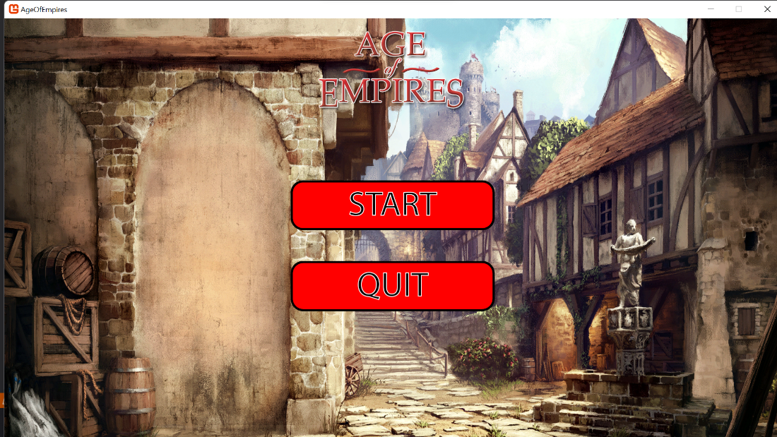

This is the wireframe for the menu, it is a rather simple menu. There is a background picture which occupies the entire background, like the picture in our sketch. There are only two buttons that the player can utilize in our demo, a "start" mode button, which will redirect the player to the game. Alongside an exit button, which will of course make the player exit the game.

## Game WireFrame

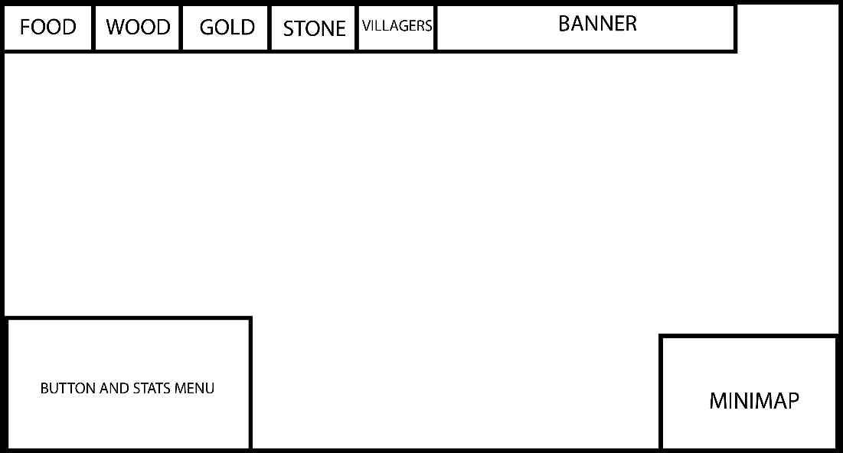

This is the game wireframe, which explains the idea behind our game, as shown here, wood counter, iron counter, food counter and gold counter in the top menu. This is to keep track of which nation you are playing as, as well as a counter for which resources you have.

In the bottom right, the unit menu is there. This is only there for when a unit or entity is selected. This allows the player to make them build specific buildings, look at their abilities and look at their health, attack and defense alongside their name. At the bottom right, the mini map is there, which shows the player what they have discovered in the actual world.

### Game

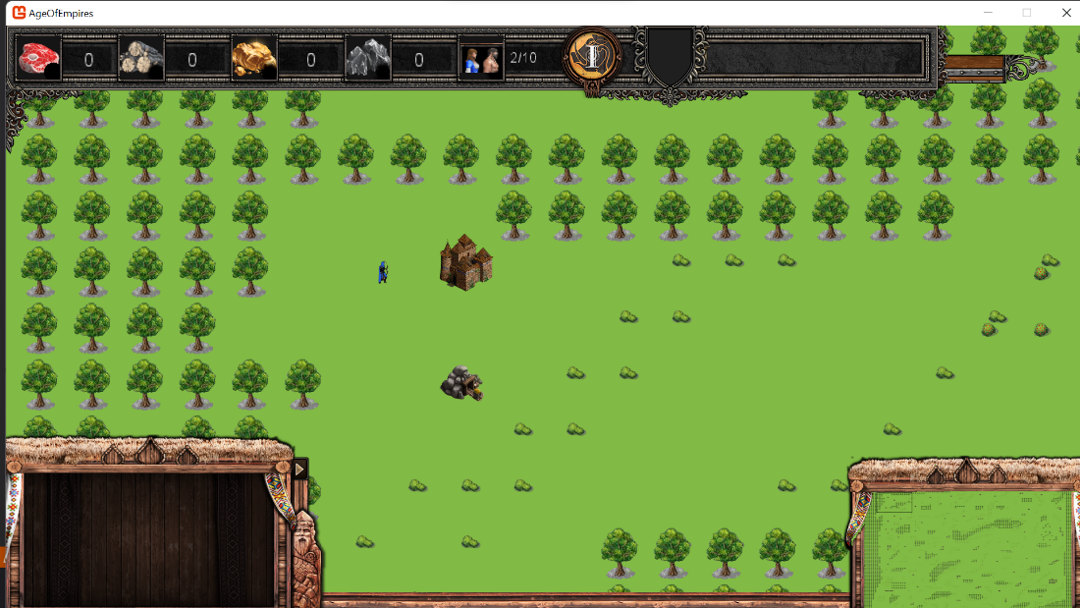

This would be an example of a screenshot out of the game, with units being on the game sheet with an area around him, including forest and plains for now. This would differ based on each campaign. Of course, buildings and animals would be added in future designs. In the user interface, the characters would be able to be moved and assigned to tasks across the map, as well as build buildings. Buildings would be able to produce units in turn. But would put their sprite on the map.

# Menus

## Army unit

### WireFrame

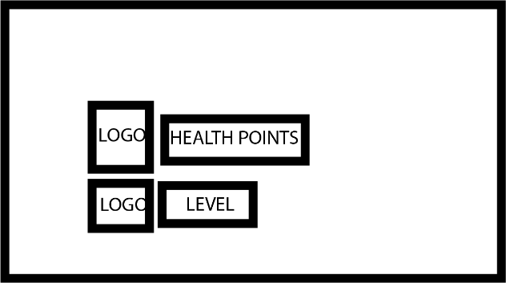

This is the wireframe for the Army units. It displays the health and current level that the unit is currently at.

### Image

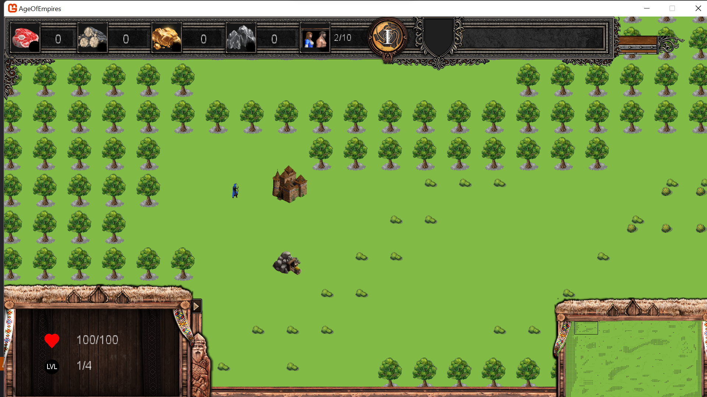

## Villager

### Wireframe

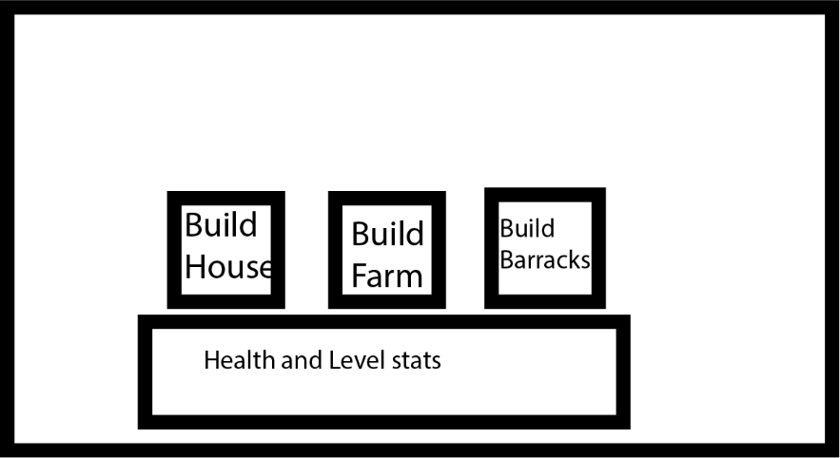

This is the wireframe when a villager is selected. The villager has the ability to build a house, a farm and barracks. These buttons only show when a villager is selected. The health and level of the villager are also shown.

### Image

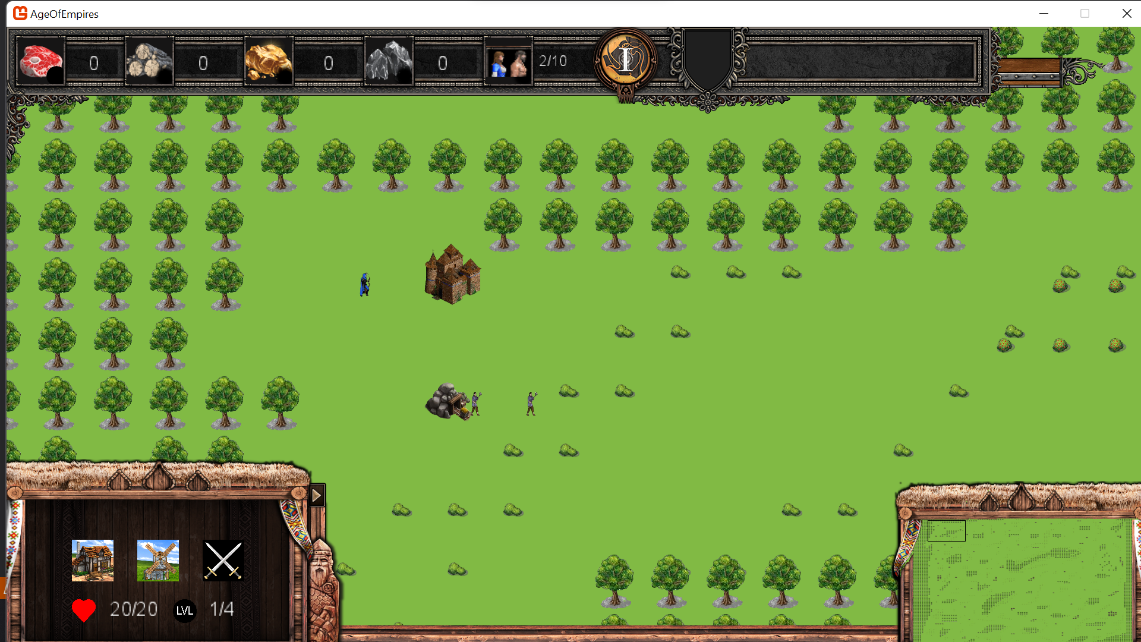

## Townhall

### Wireframe

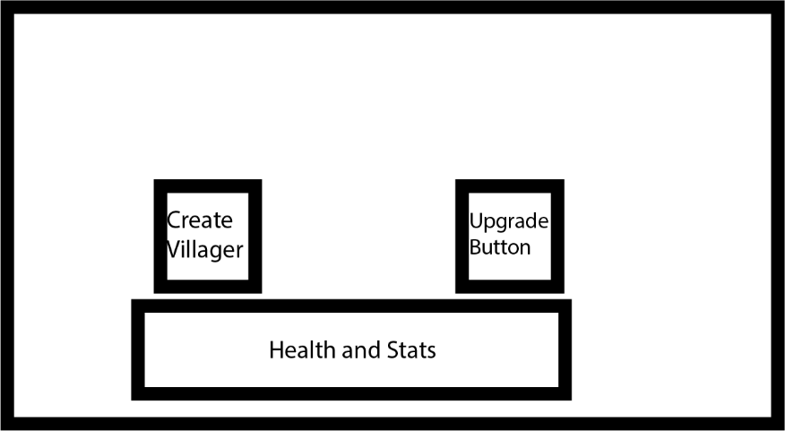

This is the wireframe for the town hall selection. The town hall has the ability to create villagers and also upgrade all the stats as it is the head of the village.

### Image

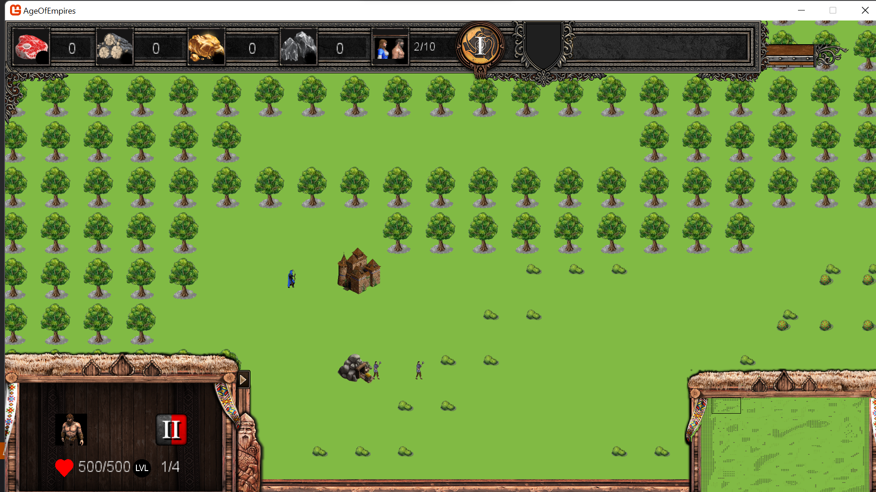

## Barrack

### Wireframe

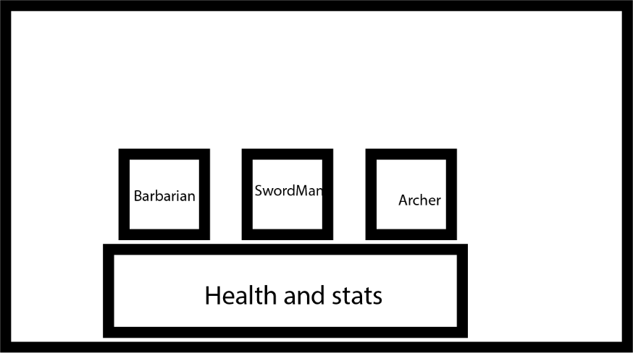

This is the wireframe of the barracks. It allows the creation of army troops. These consist of the barbarian, swordman and archer. These buttons will only create the troops if all the necessary resources are available. There is also a display of the building’s health and level.

### Image

